Code for Practical 4
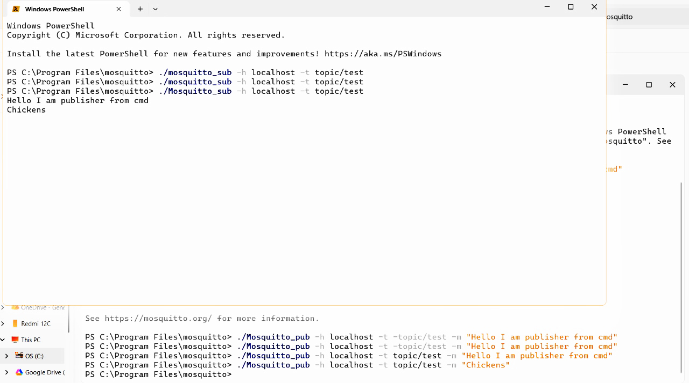
Figure 1: Publisher and Subscriber - Part 1
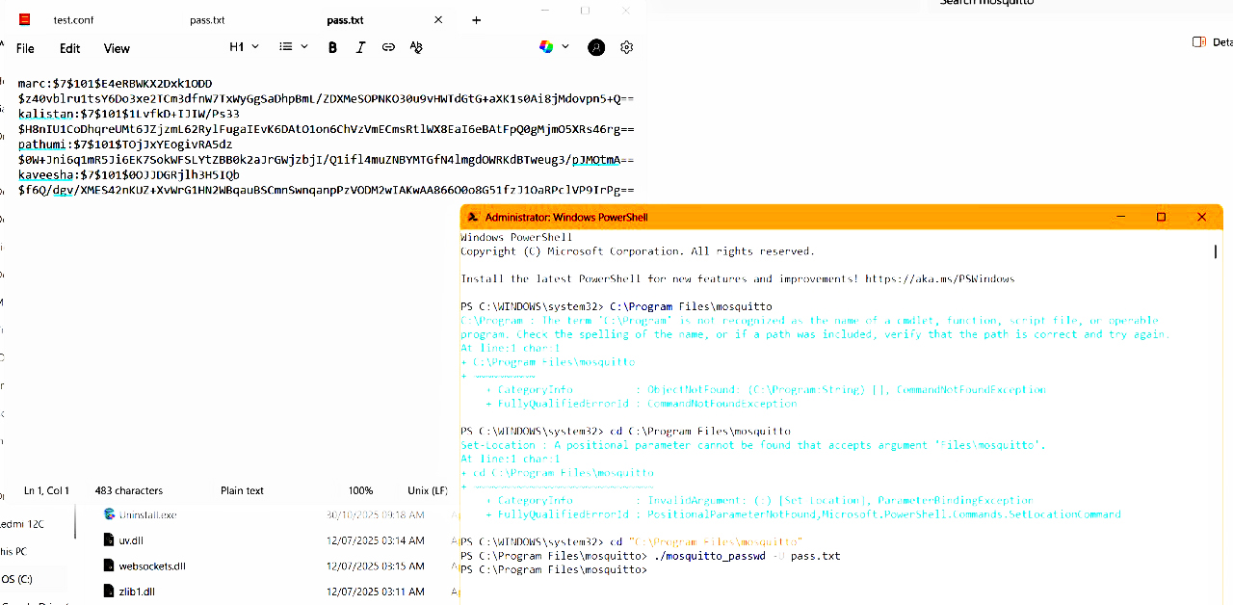
Figure 2: Creating and Hashing the Passwords
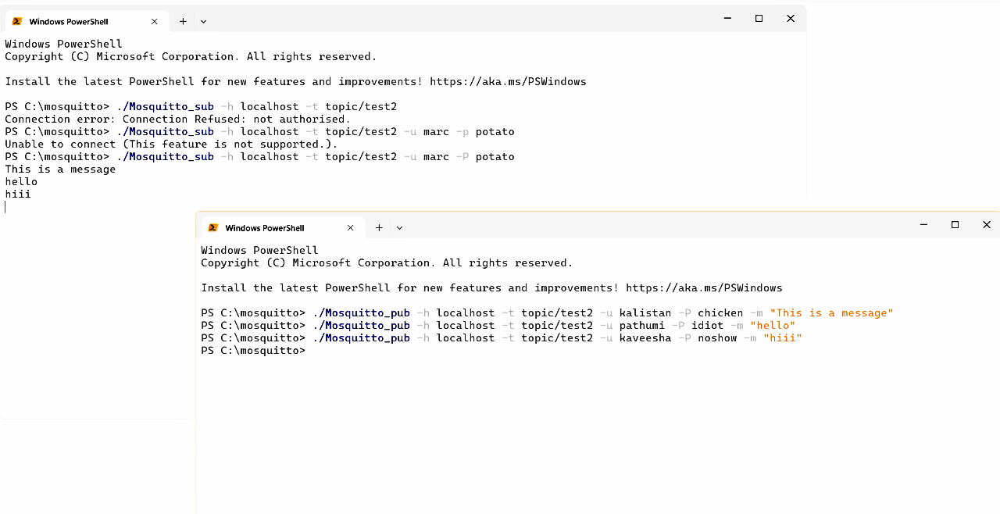
Figure 3: Publisher and Subscriber with passwords
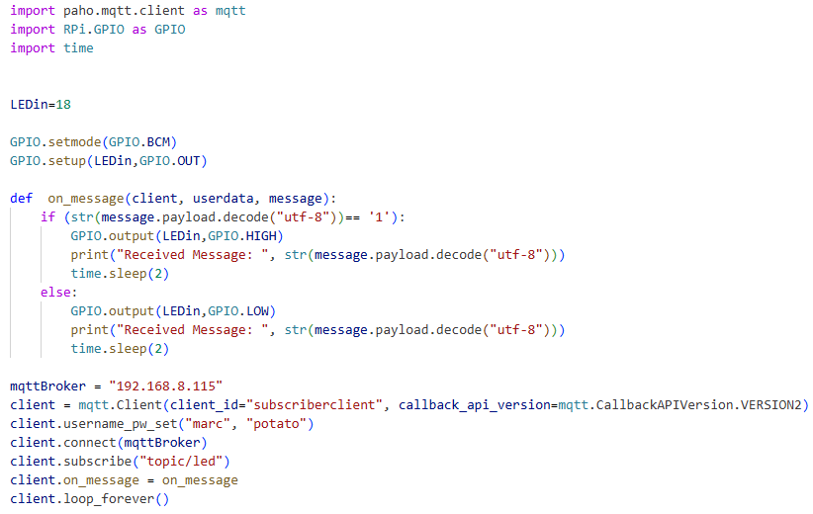
Figure 4: Subscriber Code for Raspberry Pi
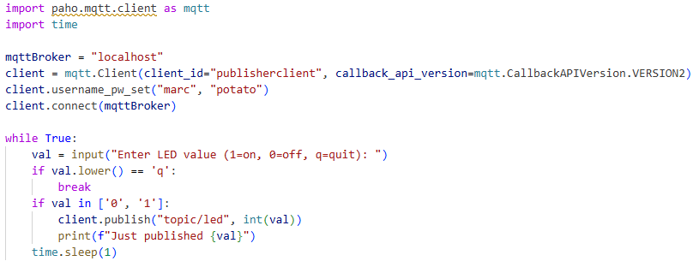
Figure 5: Publisher Code for Laptop
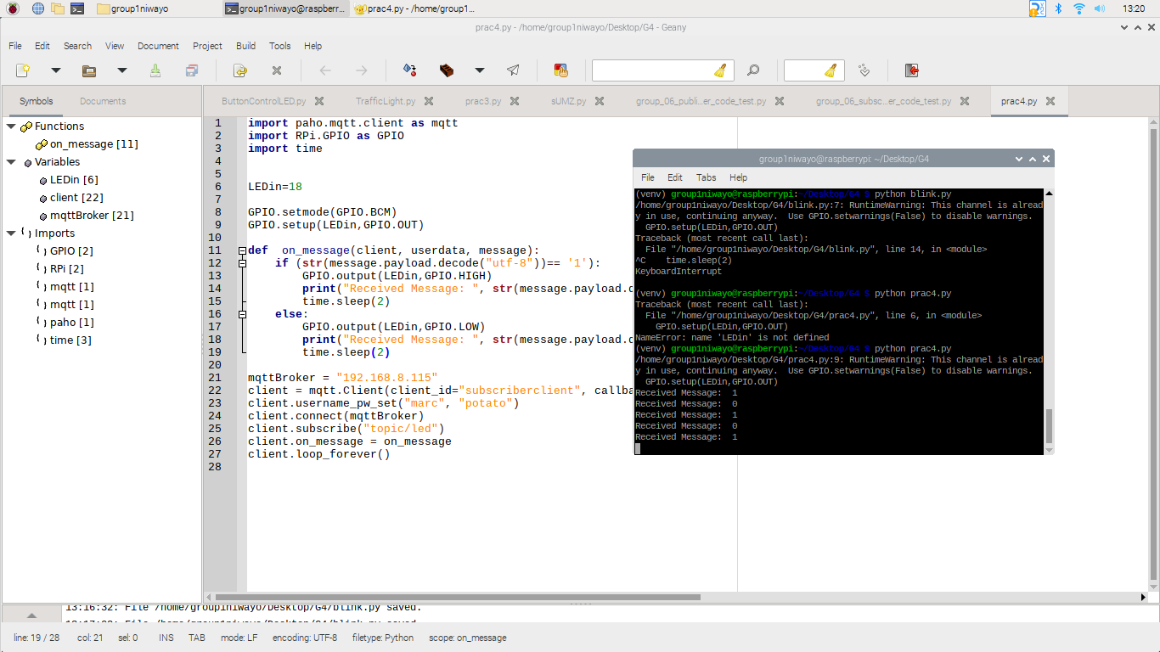
Figure 6: Case Study receiving the signal

